Cake PHP Introduction Application

- Cake is a rapid development framework for PHP which uses commonly known design pattern - MVC, which stands for Model View Controller, is at the core of CakePHP. CakePHP is Free and Open Source and can be downloaded from http://cakephp.org/
- Setting up CAKE - Configuring Apache
  - We need to make sure that the web root directory, or the directory in which we plan to keep CakePHP has AllowOverwrite set to all. We can do this by checking Apache's main configuration file http.conf. This file should be located in the directory called conf, where we have installed Apache. In this file, there should be <Directory> option for the web root directory. As the following configuration shows, the web root (which is D:/wamp/www for this particular installation) has a Directory entry in which the AllowOverwrite option is set to all. If the directory under web root, in which we plan to keep Cake, has a directory entry, we need to check that one too.
<Directory "L:/wamp/www">
Options Indexes FollowSymLinks
AllowOverride all
Order Deny,Allow
Deny from all
Allow from 127.0.0.1
</Directory>

- Make sure Mod_rewrite Module is loaded. Check in http.conf that following is uncommented:
LoadModule rewrite_module modules/mod_rewrite.so

- We will now create a sample CakePHP application. So extract CakePHP package and copy it in the root directory name the folder as “MyFirstCake”.
- Configuring Cake to Work with a Database
  - Create a database named caketoodoo in the MySQL server:
CREATE DATABASE caketoodoo;
  - In our newly created database, create a table named tasks, by running the following code in your MySQL client:
USE caketoodoo;
CREATE TABLE tasks (
id int(10) unsigned NOT NULL auto_increment,
title varchar(255) NOT NULL,
done tinyint(1) default NULL,
created datetime default NULL,
modified datetime default NULL,
PRIMARY KEY (id)
);

INSERT INTO `tasks` (`id`, `title`, `done`, `created`, `modified`) VALUES
(1, 'Task 1', 1, ‘2010-05-10 12:27:28’, NULL),
(2, 'Task 2', 0, ‘2010-05-12 12:27:28’, NULL),
(3, 'Task 3', 0, ‘2010-05-13 12:27:28’, NULL),
(4, 'Task 4', 0, ‘2010-05-15 12:27:28’, NULL),
(5, 'Task 5', 0, ‘2010-05-17 12:27:28’, NULL);

  - Move inside the directory MyFirstCake/app/config. In the config directory, there is a file named database.php.default. Rename this file to database.php.

  - Open the database.php file with your favourite editor, and move to line number 73, where we will find an array named $default. This array contains database connection options. Assign login to the database user you will be using and password to the password of that user. Assign database to caketoodoo. If we are using the database user ahsan with password sims, the configuration will look like this:
var $default = array(
'driver' => 'mysql',
'persistent' => false,
'host' => 'localhost',
'port' => '',
'login' => 'ahsan',
'password' => 'sims',
'database' => 'caketoodoo',
'schema' => '',
'prefix' => '',
'encoding' => ''
);

- Creating a Model
  - Move into the directory MyFirstCake/app/models. Here, create a file named task.php.
  - In the file task.php, write the following code:
<?php
class Task extends AppModel {
var $name = 'Task';
}
?>
  - Make sure there are no white spaces or tabs before the <?php tag and after the ?> tag. Then save the file.
- Creating a Controller
  - Move into the directory MyFirstCake/app/controllers. Create a file named tasks_controller.php.
  - In the file tasks_controller.php, write the following code:
<?php
class TasksController extends AppController {
var $name = 'Tasks';
}
?>
- Viewing All Tasks form tasks table in MyFirstCake application.
Now that the Task model and the Tasks controller are in place, let us add some functionality to our application. The first thing that we would like to do is to view a list of all the tasks. To do this, we will need to add a function to the Tasks controller, and also add a view to show us the list of tasks
  - Open the file tasks_controller.php and add a method named index to the TasksController class with the following code. Any public functions inside controller classes are called actions. So, after adding the index action code to the TasksController class, our tasks_controller.php file will look like this:
<?php
class TasksController extends AppController {
var $name = 'Tasks';
function index() {
$this->set('tasks', $this->Task->find('all'));
}
}
?>
  - Move into the directory MyFirstCake/app/views. Create a directory named tasks inside the view directory.
  - Inside the tasks directory that we just created, create a new file named index.ctp and add the following code to it:
<h2>Tasks</h2>
<?php if(empty($tasks)): ?>
There are no tasks in this list
<?php else: ?>
<table>
<tr>
<th>Title</th>
<th>Status</th>
<th>Created</th>
<th>Modified</th>
<th>Actions</th>
</tr>
<?php foreach ($tasks as $task): ?>
<tr>
<td>
<?php echo $task['Task']['title'] ?>
</td>
<td>
<?php
if($task['Task']['done']) echo "Done";
else echo "Pending";
?>
</td>
<td>
<?php echo $task['Task']['created'] ?>
</td>
<td>
<?php echo $task['Task']['modified'] ?>
</td>
<td>
<!-- actions on tasks will be added later -->
</td>
</tr>
<?php endforeach; ?>
</table>
<?php endif; ?>
  - Now if you browse http://<LOCALHOST>/MyFirstCake/tasks/index you should see like:
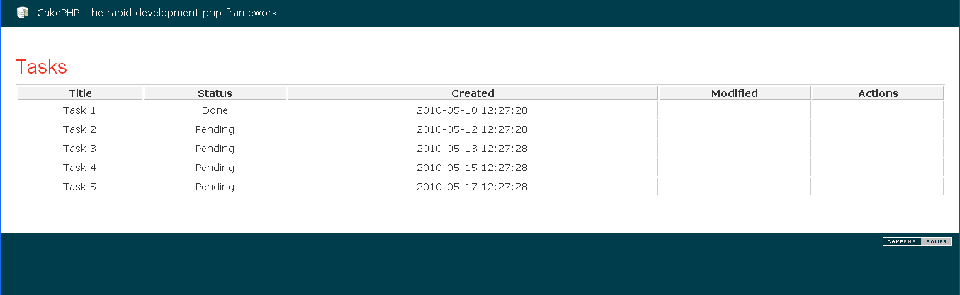

You can also refer attached code which is a sample application we have just discussed. Additional reference also can be found at the link mentioned below:
http://book.cakephp.org/view/4/Beginning-With-CakePHP

